**AIM**

To design a simple network topology with different network devices and media in logical and physical workspace. Test the connectivity between the devices.

**DESCRIPTION**

1. End devices :

The network devices that people are most familiar with are called end devices. These devices form the interface between the human network and the underlying communication network. Some examples of end devices are: Computers, laptops

2. Intermediate Devices/Network Devices:

**Hub**: A network hub is a node that broadcasts data to every computer or Ethernet-based device connected to it. A hub is less sophisticated than a switch, the latter of which can isolate data transmissions to specific devices. Network hubs are best suited for small, simple local area network (LAN) environments.

**Switch:** A switch has many ports, to which computers are plugged in. When a data frame arrives at any port of a network switch, it examines the destination address, performs necessary checks and sends the frame to the corresponding device(s).It supports unicast, multicast as well as broadcast communications.

**Router:** A router is a device that connects two or more packet-switched networks or subnetworks. It serves two primary functions: managing traffic between these networks by forwarding data packets to their intended IP addresses, and allowing multiple devices to use the same Internet connection.

3. Access Media :

**Copper cable-Straight-through:** Straight-through cable is used to connect computers and other end-user devices (e.g., printers) to networking devices such as hubs and switches. It can also be used to directly connect like devices (e.g., two hubs or two switches) if the cable is plugged into an uplink port on one (but not both) of the devices.

**Crossover**: Crossover cables These are used to connect two computers or similar devices directly together, such as computers or hubs.

**Coaxial** : Coaxial cable is a type of copper cable specially built with a metal shield and other components engineered to block signal interference. It is primarily used by cable TV companies to connect their satellite antenna facilities to customer homes and businesses.

**Optical fibre:** Optical fibres are about the diameter of a strand of human hair and when bundled into a fibre-optic cable, they're capable of transmitting more data over longer distances and faster than other mediums. It is this technology that provides homes and businesses with fiber-optic internet, phone and TV services

**COMMANDS USED IN ROUTER**

Router>enable

Router#conf t

Router (config) #interface fa0/0

Router (config-if) #ip address 192.168.1.1 255.255.255.0

Router (config-if) #no shutdown

Router (config-if) # interface fa1/0

Router (config-if) #ip address 192.168.2.1 255.255.255.0

Router (config-if) #no shutdown

Router (config-if) #exit

Router (config) #exit

Router#exit

**PROCEDURE**

1. Set the user profile. 2. Place the End devices and Network devices on the workspace. 3. Connect all the devices using appropriate cables. 4. Configure IP Addresses on the Host PCs. 5. Configure Router Interfaces. 6. Test and Verify the Configurations.

**TOPOLOGY DIAGRAM**

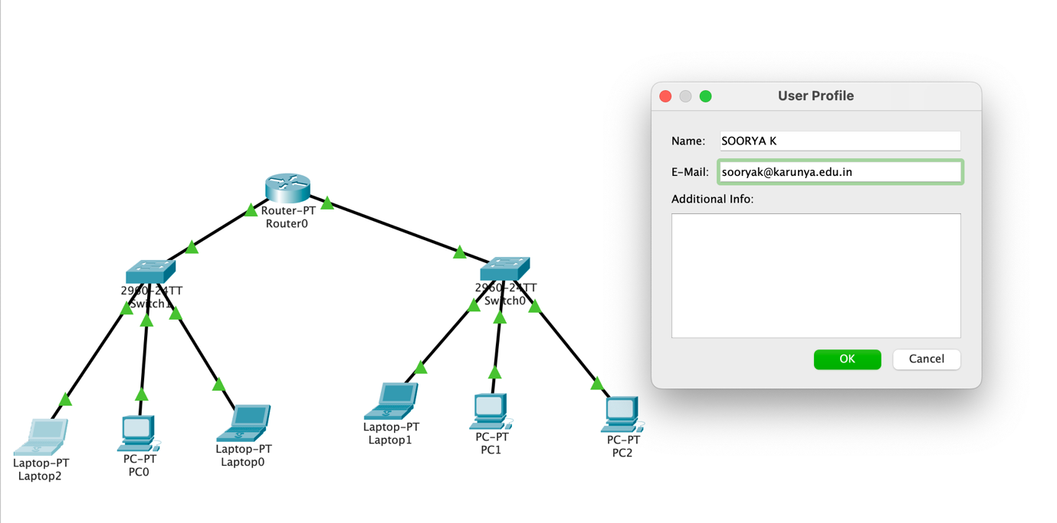

**ADDRESSING TABLE**

|  |  |  |  |  |
| --- | --- | --- | --- | --- |
| Device | Interface | Ip Address | Subnet Mask | Default  Gateway |
| R1 | Fa0/0 | 192.168.1.1 | 255.255.255.0 | NA |
| Fa1/0 | 192.168.2.1 | 255.255.255.0 | NA |
| Laptop | NIC | 192.168.1.2 | 255.255.255.0 | 192.168.1.1 |
| PC0 | NIC | 192.168.1.3 | 255.255.255.0 | 192.168.1.1 |
| Laptop | NIC | 192.168.1.4 | 255.255.255.0 | 192.168.1.1 |
| Laptop | NIC | 192.168.2.2 | 255.255.255.0 | 192.168.2.1 |
| PC1 | NIC | 192.168.2.3 | 255.255.255.0 | 192.168.2.1 |
| PC2 | NIC | 192.168.2.4 | 255.255.255.0 | 192.168.2.1 |

**OUTPUT**

Screenshot of Topology from Logical Workspace

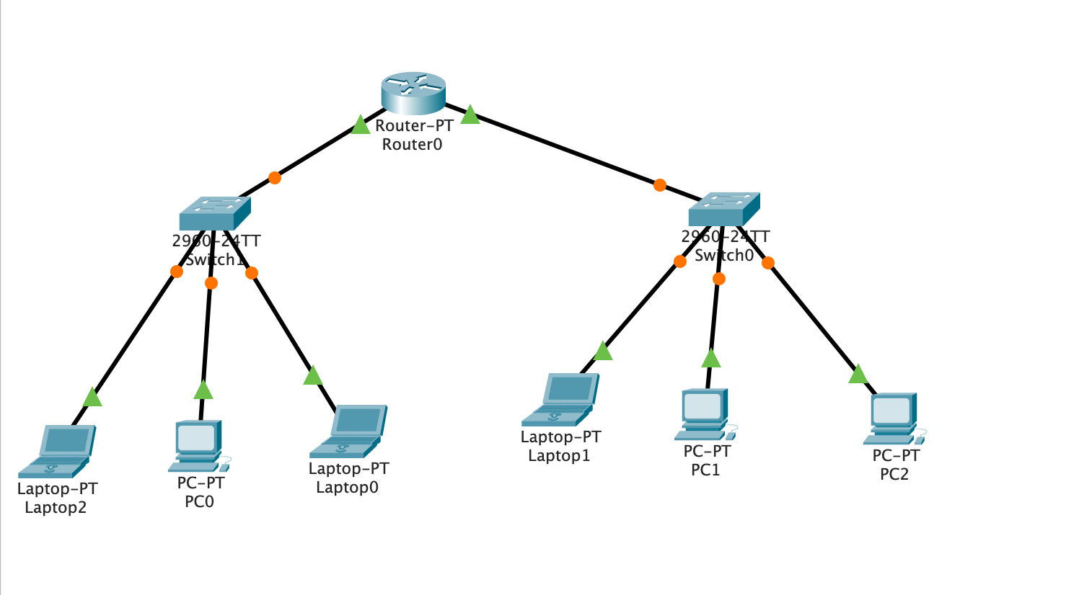

Screenshot of Topology from Physical Workspace

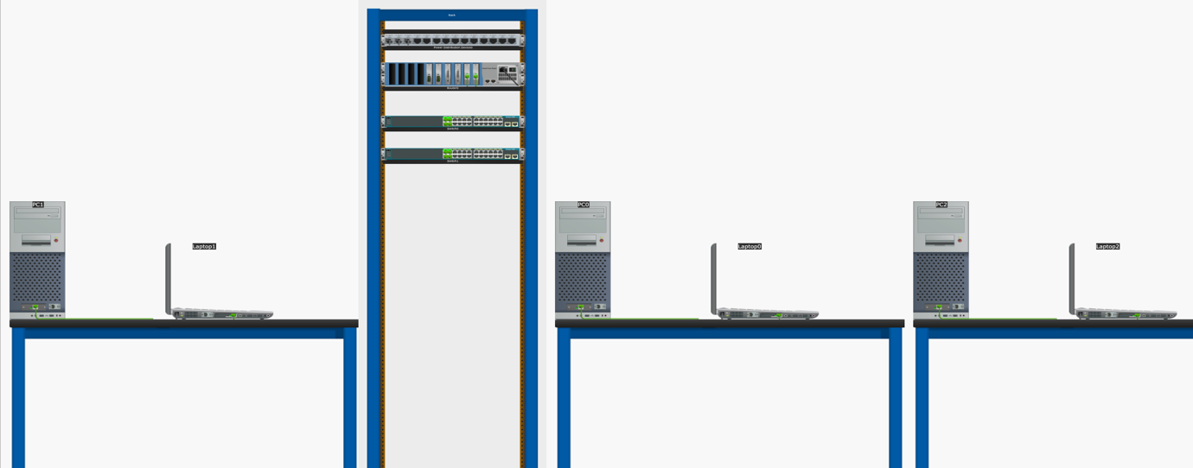

Screenshot of configuring IP address for any one PC

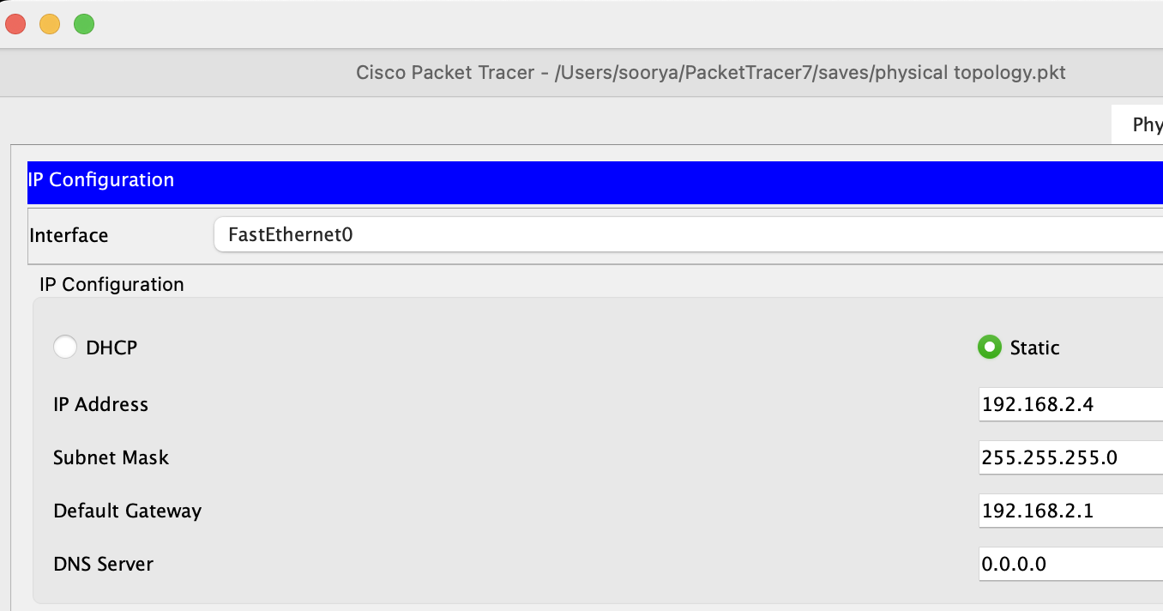

Screenshot of Successful Ping

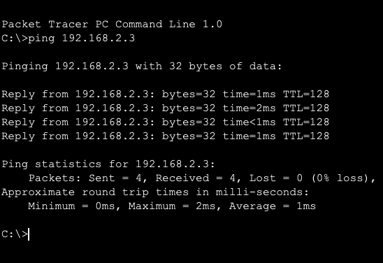

Screenshot of Unsuccessful Ping

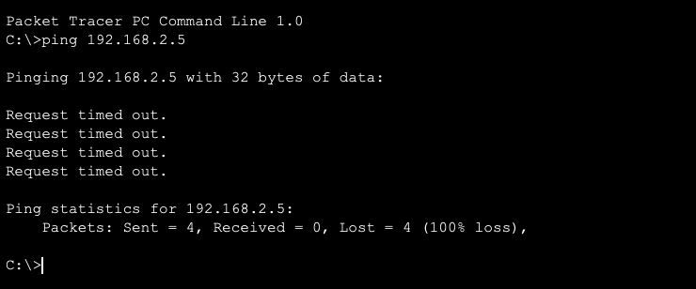

Screenshot of Routing Table

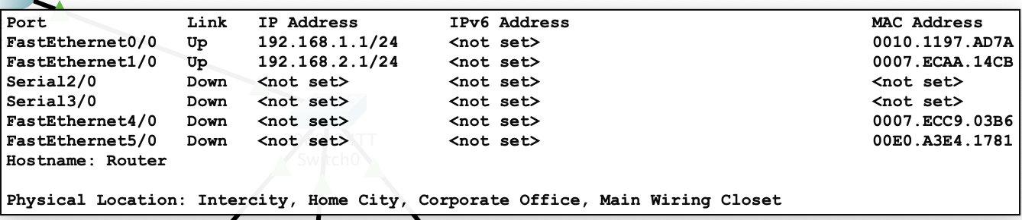

**RESULT:**

The above experiment was executed successfully and the required packages was transferred from the desired position to the desired laptop and PC.